# **Homework 1. Design & Accessibility Analysis** Yi-Ling Cheng **Composition Analysis**

# **What website did you analyze?** <https://www.chase.com/>

# Figure 1. Chase website homepage

# **What values and priorities does this website communicate (e.g., what is most important, least important, etc.)?** The most important thing is the promotion to new customers while maintaining old customers.

# The least important things are the detailed services listed when you scroll down the website.

# **How does the design help to communicate these priorities?**

# The design puts the most important thing in the middle with blue background which is easily to be scanned. The “$200”, which new customers could get, is in a bold font and much larger size to get more attention. The color composition of the website also matches the color that represents the company. The log in area is clear and easy to use. A number of services they provide are also list with related icons below, so it is easy for new customers and old customers to select what they are looking for.

# **What are the strengths of the design of this website?** - Proximity: The website groups related items together. **-** Alignment: The grouped contents in the grids all align left, which is easier for readers to read. - Contrast: Headings and sub-headings are all in larger font size compared to the related content. Words that include money are in a much larger size to attract people.

# - Repetition: Subtitles and contents in each grid are in the same fonts, colors, design elements, proximity, and alignment, respectively.

# - Color: There are only a few colors that represent the color of the brand used in the entire website. There is also enough white space, so the content is not so overwhelmed.

# - Symmetry: The top half part of the website is not completely symmetry, but the contents are display in grids. Grids and contents in similar style aligned, which make the website clean and clear. The bottom half website is symmetry displayed with a number of information.

# - All the strengths mentioned above all make the website looks clear and organized which also aligned with the profession and the type of field.

# **What are the limitations of the design of this website?** Although the contents in the bottom part of the websites are all in grids, the content length of each grid are all different, which makes the area with white space different from grid to grid. In addition, there are embedded links with different color of the contents. In some of the grids there are also some contents with bold fonts. This makes this part of the website look overwhelm, unclear, and messy. **Graphical user interface, application, table Description automatically generated** Figure 2. Bottom part of the Chase website homepage

# **Are there comparable websites that do a better job with composition?** <https://www.americanexpress.com/>

# The American Express website, also a website of a financial service corporation. The two financial service corporations both did great in their top half of websites with different style since the priority message they are communicating is different. The most important message for Chase is to have new customers open checking accounts, while for American Express, is for new customers to apply for new credit cards. The Regarding to bottom half part of the website, American Express website do not have limitation mentioned above, which makes the entire website looks clearer and simpler than Chase with similar content.

Figure 3. American Express homepage (Upper half part)

** Figure 4. American Express homepage (Bottom half part)

**Accessibility Analysis**

Below is the list of the accessibility checks I did which follow one of the assigned readings, “The 6 Simplest Web Accessibility Tests Anyone Can Do” from Karl Groves, with one additional check of screen reader.

1. Graphical user interface, website

   Description automatically generatedUnplug mouse and/ or turn off trackpad  
   The website can be interacted with all controls, links, and menus using only the keyboard “tab” key to traverse forward in the tab order; “tab” key and “shift” key at the same time to traverse backwards in the tab order; and the “enter” key to access the link. The visual focus order also matches the intended interaction order.

Video 1: Unplug mouse and turn off your trackpad, use only keyboard to interact with the website.

1. Turn on High Contrast Mode (With Chrome Extension: High Contrast)  
   There is a High contrast mode for the website (see figure below)  
   A screenshot of a computer

   Description automatically generated with medium confidence  
   Figure 5. High contrast mode for the website
2. Turn off Images

Without images, the majority content still make sense and does not become harder to understand, and there are no content missing. Also, none of any important controls disappears. One tiny issue after turning I noticed after turning off images was the text alternatives of the icon on the upper left (figure xx ) that pops up the menu. It was called hamburger. Without the image, it might be difficult for people without website design background to know that it is the place you need to click to see the menu.

Figure 6. Website after turning of the images  
  
Figure 7. Website after turning of the images, with “hamburger” text on upper left

1. Check for Captions or Transcripts  
   There is no media (videos) in the site.
2. 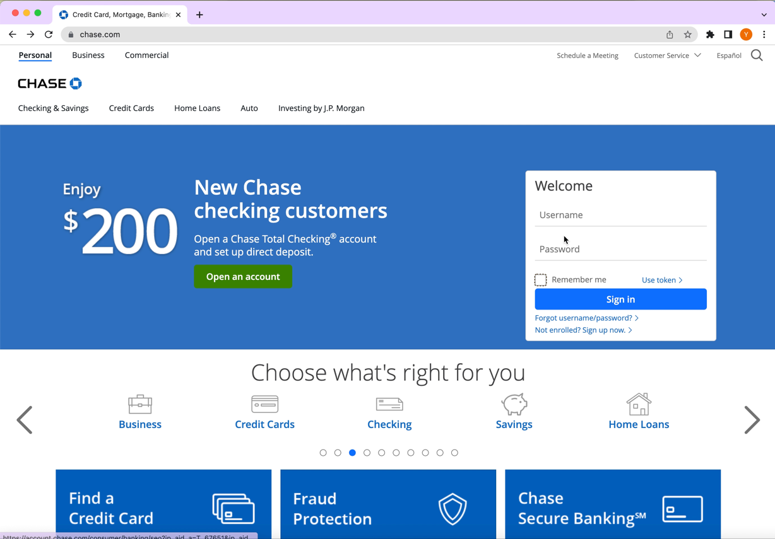Click on Field Labels  
   The cursor goes into the field, when clicking on the label next to a text input or text area.   
   The adjacent option was selected when click on the label next to a radio button or checkbox. The select element focus on the select when clicking on the label next to it.

Video 2. Accessibility checks while clicking on Field Labels

1. 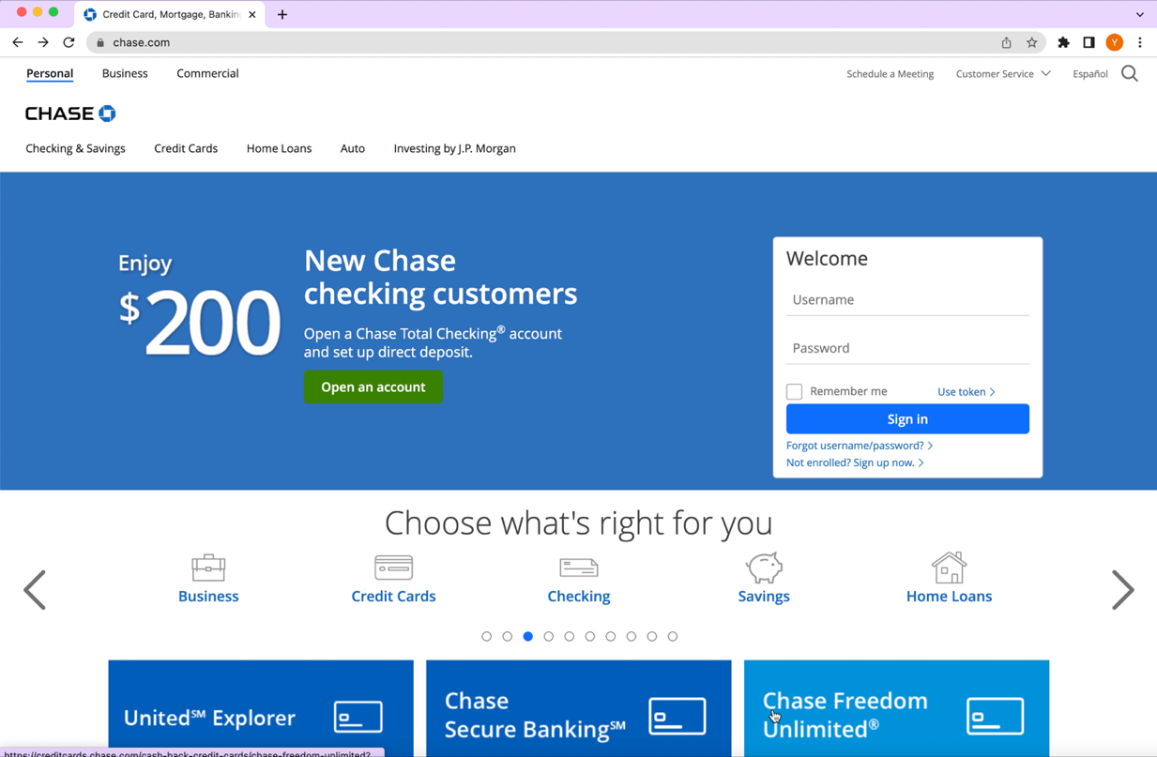Turn off CSS

Video 3. Website when turning off CSS with Web Developer Extension on Chrome

1. Check if the website enables a screen reader to access the content

The information on the website can be access through the screen reader with the building VoiceOver on MAC. (See video 4. in the next page)

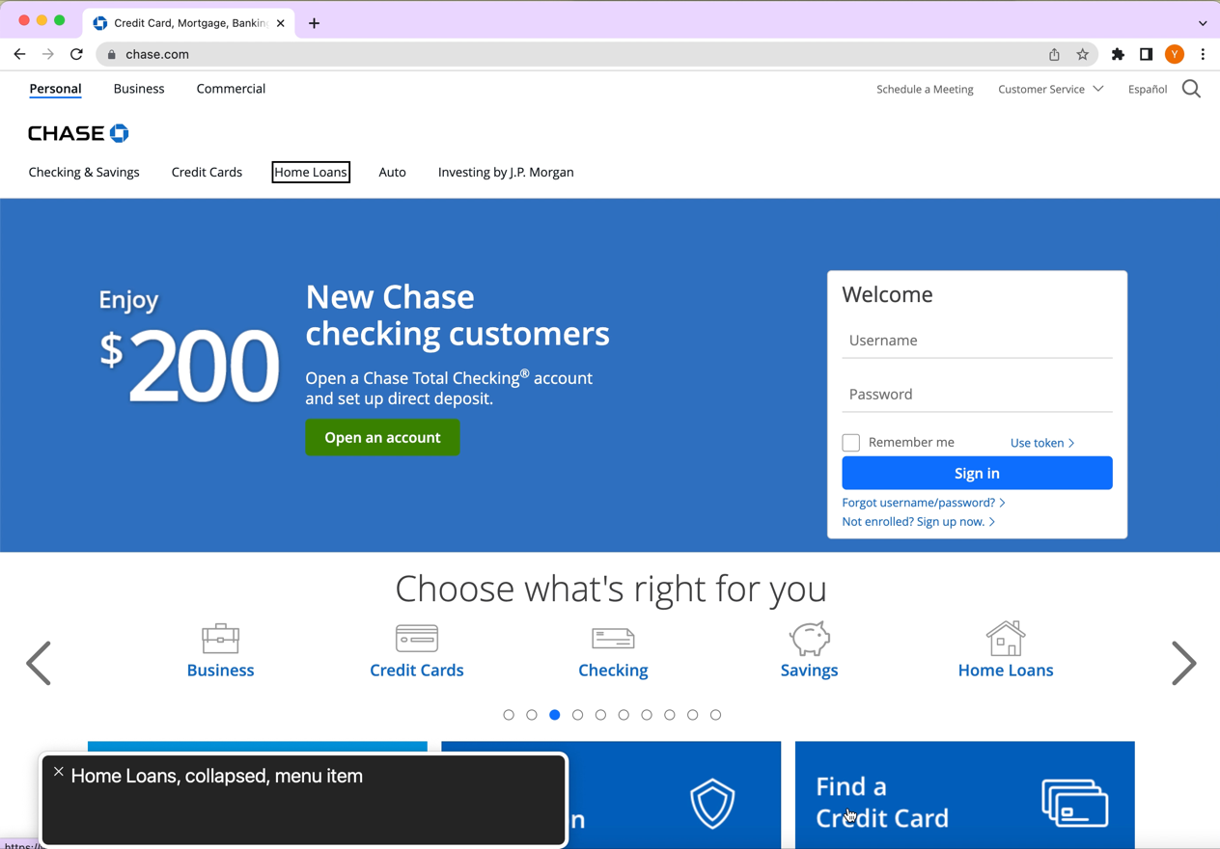

Video 4. Accessing the website with VoiceOver.

Aside from the seven checks I did above, a web accessibility testing tool, axe DevTools, was used to complete the final check of the website accessibility. There are 19 total issues detected by the axe DevTools which falls under (1) Ensure aria-roledescription is only used on elements with an implicit or explicit role and (2) Element's background color could not be determined due to a background image (Figure 8). However, none of them are critical or serious issues.

Figure 8. Website accessibility result of Chase website utilizing axe DevTools

# **How accessible was the site? What changes could/should it make to improve its accessibility**

# After my accessibility checks, I believe the website is mostly accessible. Since the results of the majority of my checks are positive, that is passed the checks I did, except a tiny issue when turning off the image and the issue that the main content did not display directly after turning off CSS. The tiny issue when turning off the image can be easily improved by updating the text alternative of the image from “hamburger” to “menu”.

About the CSS issue, I would suggest change the background logo image into a smaller size and place it on the top of the website to make the display softer. In addition, replace the entire part that is under the Please update your browser with the main content. In this way, people can still access to the main content directly when entering the site without CSS.  
The two issues detected by DevTools can be improved by checking the aria-roledescription is announced by supported screen readers and fixed the element color so it has a 1:1 contrast ratio with the background.

Figure 9. Screenshot of the website after turning off CSS. (The part that I suggest being replaced.)

Figure 10. The main content of the website after turning of the CSS (Suggested to be display directly when turning of CSS)

* **Comparable websites that do a better job with accessibility?**

Figure 11. American Express site after turning off CSS

Figure 12. Citi bank site after turning off CSS

Focusing only on the part that I found least accessible in the Chase website, the comparable websites that do better job with accessibility are American Express and Citi Bank. I choose similar type of companies, so the main content they are addressing are similar. For the two comparable websites, they do not have the issue I have when turning of CSS. Both display the main content directly. They also do not have overwhelmed huge logo appear in the background.

At first, I personally think American Express has a better design with clean layout and some nice photos. The website also has great design that follows the four basic principle of design. However, when I ran the axe DevTools for the American Express website, there are more critical and serious issues detected. In addition, I also found it hard to interact with while turning on the contrast mode. The photos on the website look great for people without disabilities, but it is hard to make the photos look the same under high contrast mode. These all aligned well with the lecture from Victoria, that “Good design is not necessarily accessible.”

Figure 13. Website accessibility result of American Express website utilizing axe DevTools

Figure 14. Contrast mode of American Express website utilizing axe DevTools